Knowledge Coxswain Deck
Participant Name | 22636VIC DEFSUR011 | Signature
RTO Name / Code | Seafood & Maritime Training 7074 | Date of Assessment
Course Name | Coxswain Deck
UoC partially mapped to this assessment | MARN008 Apply seamanship skills aboard a vessel up to 12 metres  MARJ006 Follow environmental work practices  MARK007 Handle a vessel up to 12 metres  MARC037 Operate inboard and outboard motors  MARI003 Comply with regulations to ensure safe operation of a vessel up to 12 metres
Participant Instructions on Assessment | This assessment is to be completed by participants and will be used as evidence of the participant achieving competency.  - Write your name, date and signature at the top of this Assessment  - This assessment is to be completed within the allocated time and is a closed book assessment.  - A satisfactory answer to each question is required as acceptable  - Write your answers on this assessment in the spaces provided. If you need more space to write your answer, use a blank sheet of paper obtainable from your trainer  Resources Required:  - AMSA Website, Marine Orders and MARPOL.
Assessment Outcomes: | S – Satisfactory or NS – Not yet Satisfactory
Part1: Ropework & Lifting Equipment |  |  | S / NS | Part 5: Outboards |  |  | S / NS
Part 2: Domestic Regs. |  |  | S / NS | Part 6: Environmental considerations |  |  | S / NS
Part 3: Anchoring & beaching |  |  | S / NS | Part 7: Construction & maintenance |  |  | S / NS
Part 4: Pre-start checks/Voyage Planning and Refuelling |  |  |  |  |  |  | S / NS
Within the scheduled duration of the training and assessment if the participant is found not satisfactory, please fill in a Participant Development Report.
In finding the participant satisfactory they have met the requirements of this assessment:
Trainer/Assessor Name: ____________________ Signature: ____________________________
Date: ______________________

Assessor Notes:  While undertaking the scheduled training | E.g. Q1 – needs a more detailed answer.  ________________________________________________________________________________________________________________________________________________________________________________________________________________________________________________________________________________________________________________________________________________________________________________________________________________________________________________________________________________________________________________________________________________________________________________________________________________________________________________________________________________________________________________________________________________________________________________________________________________________________________________________________________________________________________________________________________________

Part 1: Ropework and Lifting Equipment | S | NS
- How do you work out the Working Load Limit (WLL) of a lifting sling?

N008-K10
- What will you use as the maximum WLL if the limit for a crane is 2,000kg and the WLL for the lifting sling is 1,700kg?

N008-K10
- Which rope would be chosen for the following applications? Join the ropes with the preferred use.

Nylon | Floating rope that will not rot
Polypropylene | Shock loading and elasticity
Natural Fibre | Winch drum and Hoist operations
Flexible Steel Wire Rope (FSWR) | Tag lines on lifting operations

N008-PC1.1, K19
- What are four (4) things you would look for when inspecting ropes for damage?
1. ________________________________________________________________
2. ________________________________________________________________
3. ________________________________________________________________
4. ________________________________________________________________
N008-PC1.2, K11, K19
- What are three (3) safety considerations when working around ropes and loads under tensions?
1. _______________________________________________________________
2. ________________________________________________________________
3. ________________________________________________________________
N008-K10

Part 2: Domestic Regulations | S | NS
- List three (3) pieces of Legislation that apply to a Domestic Commercial Vessel (DCV) and its crew?
1. ________________________________________________________________
2. ________________________________________________________________
3. ________________________________________________________________
I003-PC1.2, 3.1, 3.4: P4, K5, K11, K13, K15, K17

- What documentation onboard the vessel outlines the duties, responsibilities and authority of the Master and crew?

I003-PC1.2, 3.4: P4, P5. K17

- What is the minimum crew (core complement) required for a DCV less than 12 metres operating in D Class waters?

I003-PC1.3, 2.1, 3.1, 3.4, P5

- What are the certification requirements for Master of a DCV less than 12 metres operating in D waters?

I003-PC1.3, 2.1, 3.1, 3.4, 5.2, K2, K11, K13

- Refer to Marine Safety (Domestic Commercial Vessel) National Law Act 2012 Part 5
What must the Master of a vessel do on becoming aware of another vessel in distress?

I003-PC1.2, 3.1, 3.4: P1, P2, P4, P5, K1, K5 / J006-PC3.2
Refer to Part B of the NSCV.
- What service category would a vessel carting cargo in waters between Triabunna and Darlington on Maria Island fall under?

I003-PC3.3, P1, P2
Refer to Marine Orders 504
- What are four (4) emergency situations for which crew should receive inductions?
1. _________________________________________________________________
2. _________________________________________________________________
3. _________________________________________________________________
4. _________________________________________________________________
I003-PC3.3, P2, P3, K5, K15, K17

Refer to Part B of the NSCV.
- What service category would a vessel carrying passengers in waters between Port Arthur and Eaglehawk Neck fall under?

I003-PC3.4, P1, K14, K16
- List four (4) documents that must be accessible to the operator of a <12 metre Class 2C surveyed vessel?
1. _________________________________________________________________
2. _________________________________________________________________
3. _________________________________________________________________
4. _________________________________________________________________
I003-PC3.4, 5.1, 5.2, P2, K13, K14, K16 / J006- PC3.2

- List five (5) critical pieces of information you must record in your vessel logbook.

1. _____________________________________________________________
2. _____________________________________________________________
3. _____________________________________________________________
4. _____________________________________________________________
5. _____________________________________________________________
I003-PC3.4, K10
- As the Master of a DCV, how do you keep up with changes to industry and Legislation?

I003-PC4.1, 4.2, 4.3
- Once changes to Regulations and Legislation have been identified, what must you do?

I003-PC2.2, 4.2, 4.3, 5.1, 5.2
- List five (5) pieces of Safety Equipment required for a 10m, 1D vessel as stated in the NSCV Part C Section 7 subsection 7A.


Distress Signals:___________________________________________________
Navigation Equipment:_____________________________________________

Onboard communication:___________________________________________

Firefighting equipment: ____________________________________________

Lifejackets: _______________________________________________________
I003-K6, K13, K17

Part 3: Anchoring and beaching | S | NS
- What are three (3) factors you would consider when selecting an anchorage?
1. _____________________________________________________________
2. _____________________________________________________________
3. _____________________________________________________________
N008-PC2.1, 2.2, K3, K17 / J006-PC1.2, K4 / K007-P1
- Select the anchor/s when anchoring on a soft mud seabed (Circle your selection)
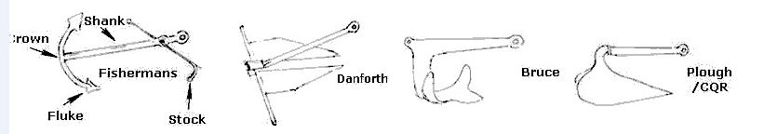
N008-K1, K3,
- What are two (2) ways you can check whether an anchor is dragging?

1. _____________________________________________________________
2. _____________________________________________________________

K007-P1 / N008-PC2.2,2.4, K17
- List three (3) things you can do if your anchor is dragging?

1. _____________________________________________________________
2. ______________________________________________________________
3. _______________________________________________________________
N008-PC2.4, K17 / K007-P1
- What are two (2) emergencies that might lead to you beaching a vessel?
1. ______________________________________________________________
2. ______________________________________________________________
K007-PC3.1, K5
- What are three (3) considerations for re-floating a beached vessel?

1. ______________________________________________________________
2. ______________________________________________________________
3. ______________________________________________________________
K007-P3, K8

Part 4: Pre-start checks/Voyage Planning and Refuelling | S | NS
- What would you do if any equipment required on your vessel by NSCV is not functioning?

b) Would your vessel be legally seaworthy?

Yes / No

N008-PC4.4, 4.5, P1 / C037-PC1.1
- Name three (3) pieces of equipment you would test prior to departure?

1. ________________________________________________________________
2. ________________________________________________________________
3. ________________________________________________________________
C037-PC1.1 / N008-PC4.2

a) How much fuel will you use if your voyage plan involves eight (8) hours of operation, and your fuel consumption is twelve (12) litres per hour?

- If you follow the advice of the voyage planning and allow for between 1/3 and ½ extra, how much fuel should you have on board for the voyage?

- How could you check your fuel consumption after 1 hour?

J006-PC1.1 / C037-PC1.2, P4
- When would you report a fuel spill to authorities?

J006-PC1.6, 2.1, K6 / N008- K18
- What are three (3) precautions that will help to reduce the risk of a spill when refuelling?

1. ________________________________________________________________
2. ________________________________________________________________
3. ________________________________________________________________

N008-PC5.3, P11, K18, K20 / J006-PC1.4, K10, K11
- List four (4) systems or pieces of equipment that you should shut down prior to refuelling?

1. ________________________________________________________________
2. _________________________________________________________________
3. _________________________________________________________________
4. ___________________________________________________________

N008-PC5.2, 5.4 / J006-PC1.4 / C037-PC2.2
- List four (4) activities that should be restricted within a ‘safety zone’ while refuelling?
1. ________________________________________________________________
2. _________________________________________________________________
3. _________________________________________________________________
4. ___________________________________________________________

N008-PC5.2, 5.3, 5.4
- In the event of a spill, what procedures should you follow?

J006-PC1.4, 1.5, K6, K10 / N008-PC5.2, 5.4

Part 5: Outboards | S | NS
- If you couldn’t start the outboard motor, list three (3) checks you would make?

1. ________________________________________________________________
2. _________________________________________________________________
3. _________________________________________________________________
C037-PC1.1, 3.3, 3.4, 4.1, 4.2, 4.3, K6
- When using a motor, what are four (4) pre-start checks should you make?

1. __________________________________________________________________
2. __________________________________________________________________
3. __________________________________________________________________
4. __________________________________________________________________
C037-PC1.1, 1.2, 3.3, 3.4, P2
- Name two (2) hazards associated with batteries?

1. _________________________________________________________________
2. _________________________________________________________________

CO37 -K1, K7
- What are three (3) post-start checks you should make if the engine is running roughly?

1. _______________________________________________________________
2. ________________________________________________________________
3. ________________________________________________________________

C037-PC4.1, 4.3, K3, K6

Part 6: Environmental considerations | S | NS
- How many Annex make up the International Convention for the Prevention of Pollution from Ships (MARPOL)?

J006-PC1.1, 1.2, K2, K5, K8/ I003-K12
- What provision should you make for garbage disposal, and recyclables when operating a small vessel within 10nm of shore to comply with MARPOL?

J006-PC1.1, 1.2, 1.3, 3.1, K2, K3, K5 / I003-K12
- What are the advantages of compacting waste onboard your vessel?

3a. List one (1) way of compacting ‘general’ waste on a DCV?

J006-PC1.1, 1.3, K5 / I003-K12
- What do you need to consider when storing fuel, waste oil, and chemicals on your vessel?

J006-PC2.2, K1, K5, K7 / I003-K12 / C037-PC2.4
- Where can you discharge sewage at sea in Tasmania?

J006-K2, K5, K6 / I003-K12

- List two (2) environmental impacts from the following;

Anchoring

Noise

Propeller wash

J006-PC1.1, 1.2, K4, K5

Part 7: Construction and Maintenance | S | NS
- Why are watertight compartments important?

N008-K2, K6, K7, K8.
- When inspecting the integrity and condition of a hull, what are three (3) signs of damage you would look for?

1. _________________________________________________________________
2. _________________________________________________________________
3. _________________________________________________________________

N008-P2, P5, K6, K8

- What types of damage or deterioration would you look for in vessels constructed of the following?
Steel _________________________________________________________
Wood _________________________________________________________
Aluminium ______________________________________________________
Fibreglass ______________________________________________________
N008-P2, P5, K6, K8

- Identify the following structural parts of a vessel and place appropriate numbers by each part.
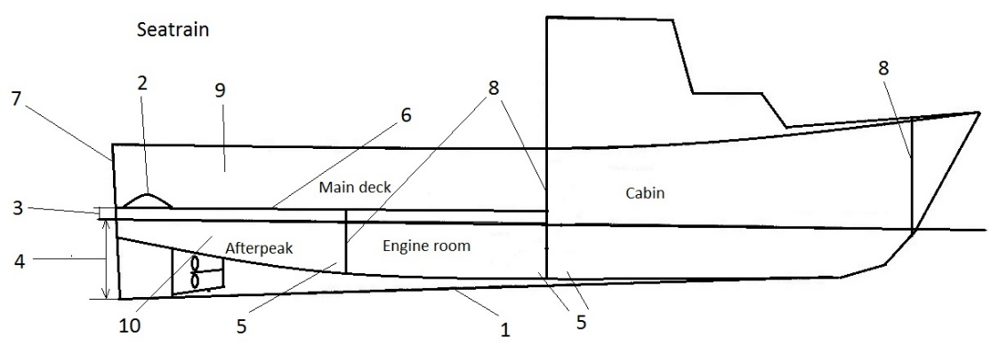
Freeboard _______  Stern _______  Scuppers _______  Bulwarks _______ | Keel _______  Draft _______  Bilge _______ | Watertight Deck _______  Watertight Bulkhead _____  Void space (empty) ______
N008-K2, K6, K7, K14
- List two (2) areas where water can enter the vessel whilst at sea

1. ________________________________________________________________
2. ________________________________________________________________

N008-K7, 14, 15, 16

